PPG AGM  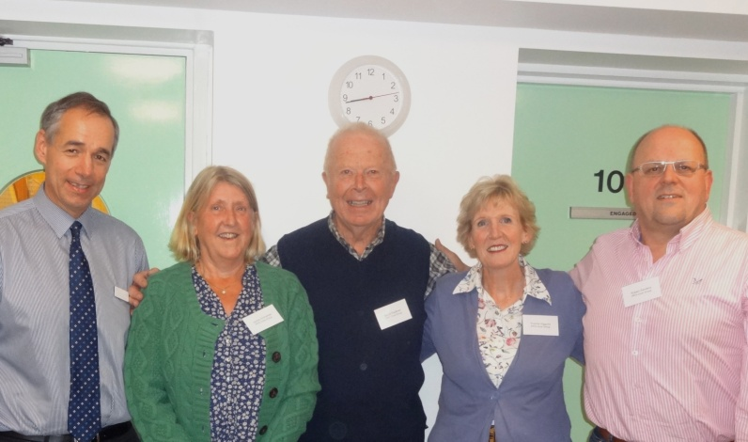  The PPG Annual General Meeting was held on 24th September. Members split into groups to discuss a wide range of issues that affect patients - from PPG meeting times to the practice website and waiting room notices. Officers, who form an active PPG Core Group, were also elected for the coming year and are pictured above: Dr. Peter Connan (ex-officio) Jackie Grimshaw, David Faulkner (Chair), Yvonne Higgons and Robert Sanders.  The practice encourages patient involvement to ensure it meets the needs of all patients as fully as possible. If you would like to join the PPG or just pass on any comment or suggestions you can contact us in two ways:  - through the HRS website by clicking on Patient Participation Group and then Contact Us  - by leaving your name and contact details in one of the PPG post boxes in each surgery  Please also feel free to speak to any of the PPG Core Group members. We will always get back to you as soon as possible.  Commissioning of Health Services  Cambridgeshire and Peterborough Clinical Commissioning Group has selected UnitingCare Partnership as the Preferred Bidder to improve older people’s healthcare and adult community services across Cambridgeshire, Peterborough and parts of Northamptonshire and Hertfordshire.  UnitingCare Partnership is a consortium of Cambridgeshire and Peterborough NHS Foundation Trust with Cambridge University Hospitals NHS Foundation Trust. From 1st April 2015, they will directly provide adult community health services and  Huntingdon Road Surgery Website  Please take a look at our website for information about the surgeries: www.huntingdonroadsurgery.co.uk Like many other patients, you can order repeat prescriptions – this is a secure service so please see the receptionist first to get your unique user name and password. We are also starting to offer the ability to make appointments online through the website. Please let us know how we can make our website more user friendly and what other information you feel might be valuable.  Fund raising for good causes  It has been a fun few months at Huntingdon Road & Girton surgeries...  Some of you may have seen the staff dressed in their denims for "Jeans for Genes" day, Spots for "Children in Need" or dressed in Pink for "Breast Cancer Awareness" or donning red noses for ...yes! Red Nose Day. There is no end to the enthusiasm the staff have in taking part to raise funds for good causes. | hold the budget for the following services:  - Urgent care for adults aged over 65 including inpatients as well as A&E services  - Mental Health Services for people aged over 65  - Adult community health services for example, district nursing, rehabilitation and therapy after injury or illness,, speech and language therapy, care for patients with complex wounds, support for people with respiratory disease or diabetes  - Other health services which support the care of people aged over 65.  The aim is to get the best possible services for older people, particularly the elderly and frail, and adults with long term conditions, providing healthcare in more joined-up and innovative ways.  Threat to the Girton Dispensary - Good News.  We are pleased to report that the application to open a Pharmacy in Girton village has been withdrawn. This will allow the Girton Dispensary to remain open, and continue to provide dispensary services to Girton residents. We feel this is no small part due to the tremendous support we received from our patients and the community of Girton. Thank you!  Flu Vaccine  Influenza vaccines are being offered again to help protect those patients who may be at greater risk of developing more serious complications. Flu vaccines are also being offered to children aged 2 and 3 years in the form of a nasal vaccine.  Please see our website for further information  The influenza vaccine program saves lives  We are also now recommending Shingles Vaccines as part of the NHS programme for people aged 70 years and for people who are 78 or 79 who have not already received the vaccine. Ask your Doctor or Nurse  Dementia awareness for everyone  Do you want to know more about dementia and how to cope if you or any of your family or friends is affected? Then please come along to Huntingdon Road surgery at 6.30.pm on Wednesday 14th January 2015, when a range of experts will give their views and provide the opportunity for you to ask any questions you may have.  from dressing up to baking cakes and putting money in the pots!  We had our first ever "Surgery Bake Off" this year, everyone took part in one way or another whether it was baking, judging or being a part of the audience. The judges were Dr Connan and Dr Flinn, Nurse June and Office Manager Eileen Gladman....they did a wonderful job. First Place went to Dr Roque, second went to our secretary, Amy and third to receptionist Sharon.  We have recently had two Saturday morning flu clinic tombolas and cake sales raising £190.16 for Breast Cancer Care (it always cheers the patients up after their injections!)  We have another "Bake Off" competition in November, this time the theme is “Pies & Puds”, the tension is already mounting...watch this space for up to the minute news.

How to get the right treatment
If you become ill or injured and need medical help or advice, get the best possible care by choosing the right service for your needs.
Self care | e.g. Hangover. Grazed knee. Sore throat. Cough | Stock up your medicine cabinet. Don’t forget you can consult any pharmacist if in doubt.
Pharmacist | e.g. Diarrhoea. Minor infections. Headache. | NHS website can provide information on local pharmacies and opening hours  https://www.nhs.uk/Service-Search/Pharmacy/
Huntingdon Road Surgery | e.g. Feverish children. Vomiting. Ear pain. Sore tummy.Backache | Make an appointment with your Common Ailments Nurse or GP when your illness or injury just won’t go away
Huntingdon Road Surgery – minor injuries | e.g. Cuts. Strains. Sprains | Minor injuries can be treated by the doctors and nurses at Huntingdon Road Surgery
NHS 111- out of hours help | e.g. Out of hours help if you have a medical need that can’t wait | Call the normal surgery number and you will automatically be diverted to emergency support for your needs to be assessed and treated appropriately
Emergency – call 999 or go direct to Addenbrookes Hospital | e.g. Choking. Chest pain. Blacking out. Blood loss. | Addenbrookes Hospital for critical or life-threatening situation

