Huntingdon Road Surgery  CQC overall rating: OUTSTANDING!  The Care Quality Commission (CQC) inspected Huntingdon Road Surgery on Tuesday 5th April 2016 and we were very pleased that the Surgery was rated as Outstanding. Only 4% of Practices are rated as Outstanding. You can see a full copy of their report on our website and on the CQC website. They specifically commented on our procedures to help ensure patient safety, particularly safeguarding children and infection control, as well as seeing the Surgery as being well led. The process of inspection has helped us look at how we can improve things further, with ideas to encourage patients to give more feedback through comments and suggestions, and to ensure people who care for other people are immediately recognised, for example. The inspectors also recognised the contribution the Patient Group has made, and we are extremely grateful for this. Do have a look at the report. We understand our next CQC inspection will be in 5 years’ time.  New signs for the surgeries  We now have new signs at both the Huntingdon Road and Girton Surgeries, which we hope will make it easier for new patients to find us. We will be introducing the same “branding” at the top all our letters and other communications in the future.  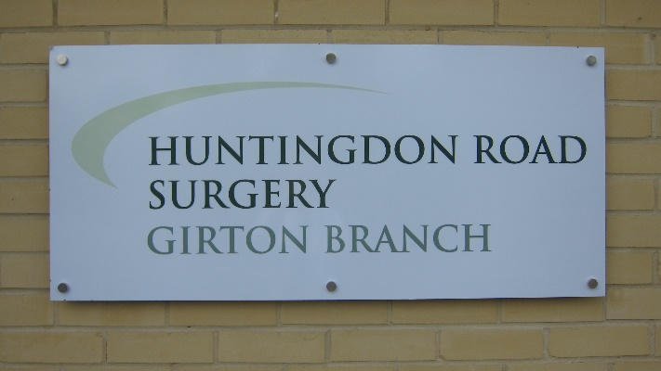  Dr. Evans’ Retirement  Dr. Evans retired from Medicine in April this year after 33 years of commitment and dedication to the Surgery. We are certainly missing her, and know that her patients miss her too. During her working life she has helped a huge number of people and has  Friends and Family Questionnaire  We are always keen to have feedback from patients. Please do complete one of the Friends and Family questionnaires, which you will find in the waiting rooms downstairs at Huntingdon Road and Girton Surgeries, and simply post them in the box. We do look at the suggestions and comments you make. We have been highlighting the questionnaires on the last Friday of each month, but you can complete one any time. We do want to hear your thoughts.  Travel Advice  Huntingdon Road Surgery offers a travel advice service to patients registered here. We are also a registered Yellow Fever Centre. Planning well for a trip overseas is important, to try and minimise health problems when you are away, which may interfere with the enjoyment or the success of your trip.  If you require any vaccinations relating to foreign travel, please make an appointment with the practice nurse to discuss your travel arrangements. It is important to make this initial appointment as early as possible, ideally at least 6 weeks before you travel, as a second and subsequent appointments may be required with the practice nurse to receive the vaccinations. For more information please see the practice website at: www.huntingdonroadsurgery.co.uk  Some travel vaccines incur a charge. This is because not all vaccinations are included in the services provided by the NHS.  Read the latest health advice for the country you're travelling to and check the travel safety updates with the Foreign & Commonwealth Office.  Make sure you have appropriate travel insurance that will cover all the activities (e.g. water-skiing, scuba diving) that you plan to undertake. | left a legacy of procedures and protocols at the Surgery recognised in our CQC rating, contributing to the standard of care we hope to provide for our patients. Thank you Dr. Evans; we hope you are enjoying your retirement.  Dr. Evans’ patients have been added to the other doctors’ patient lists, and we have appointed a new doctor, Dr. Joanna Tomlinson, to help provide urgent appointments for patients.  Dr. Towl is currently on Maternity leave and we look forward to her returning to work later in the year. We are delighted to say that she has had a little boy called Henry, who always seems to be happy and smiling whenever he comes to visit.  New Staff  Since the last newsletter we are delighted to have welcomed other new members of the team, as well as Dr. Tomlinson:  - Cathy Thorburn and Jacqueline Allen, Phlebotomists  - Penny Binks, Prescriptions Clerk  - Beverley Biggs and Veronica Fedele, Receptionists  - Jennie Williams, Notes Summariser  DNA Appointments  We are averaging 215 'did not attend' appointments every month, which is much higher than we would hope. Please think of others that need appointments, and let us know if you are not able to attend the appointment that you have booked. Thank you.  When travelling in Europe, make sure you have a valid European Health Insurance Card (EHIC). This will entitle you to free or reduced-cost medical care. However, the EHIC won’t cover you for everything that travel insurance can, such as emergency travel back to the UK.  Activities of the PG Committee  The PG Committee works with the practice staff to help improve a service that is already recognised as being excellent.  A major focus for us has been to improve communication and the exchange of information both on the website and in the surgery. We also look at your comments, suggestions and complaints (anonymised) to see what lessons the practice can draw from these and what improvements might be made. We have also organised excellent and well attended information sessions on difficult but important topics such as living with dementia, cancer, hearing loss, and how to prepare for end of life.  The Committee is a small, friendly, hard working group and new members are very welcome. The total commitment is a few hours a month including one planning meeting held in the evening.  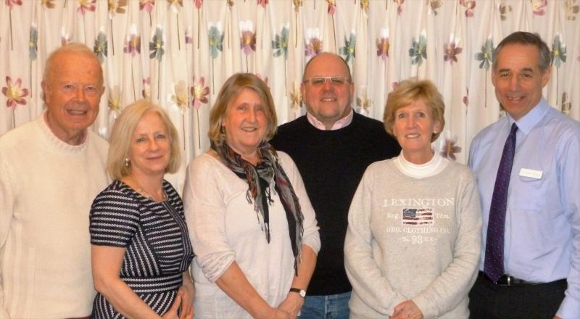  We are particularly keen to attract people who would be interested in helping Jackie, our Secretary, or who would be interested in representing the group at the monthly “CATCH” meetings of Cambridge based Patient Participation Groups. If you would like to become involved in this very important work please contact our chairman, David Faulkner via the Patient Group Contact Us tab on the surgery website for an informal chat.

