Staff News
We are delighted that Dr Helen Dumigan, previously a Registrar with us, has joined us as an Acute Care GP. Andrea Griffiths is our new Registrar, and we are in the process of recruiting a replacement for Dr Maguire.
Welcome - Lauren Rowney and Michelle King have joined the administrative team. Please join us in welcoming them all to the Practice.
Cheerio - We are very sorry to be losing Nina Runham from the Girton Surgery, but wish her all the very best in her new role.
EPS
From 1st July we have been offering an Electronic Prescription Service. Instead of prescriptions being collected from reception by the patient or courier, we can now send them electronically to the patient’s chosen pharmacy.
You will need to continue to request your prescription yourself, via our website, or through your pharmacy. We do not accept prescription requests over the phone.
Book Appointments Online
Have you signed up to book appointments and order repeat medication online via our new website? You can also view test results and medical records (from the date of the request). Please call into reception with some ID, to register for this service.
Extended Hours
Evening and weekend appointments to see a GP or a nurse are available to all patients for routine issues. Our patients can be seen at Nuffield Road Medical Centre, Ely or Comberton Surgeries. Our reception will offer these appointments to you when you call.

Flu Vaccines – Book an Appointment Now!
Are you eligible for a flu vaccination? Flu Clinics are available now at Huntingdon Road. Ring 01223 364127 or ask at reception.
Patient Group Thanks and Welcome
A huge thank you and cheerio to Jean Harding, Yvonne Higgons, and David Faulkner, whose commitment to the Patient Group over many years has been much valued by the Partners and staff at Huntingdon Road and Girton Surgeries.
Welcome to Jennifer Deegan and Sue Mudie, who join us as new Committee Members.
Join the Patient Group
The Patient Group is a voluntary organisation that provides a communication bridge between the patients and staff at the surgery. It helps us to plan services that will best meet the current and future needs of our population.
Apply to join at the surgery reception or online: http://www.huntingdonroadsurgery.co.uk
The Patient Group is a member of NAPP:
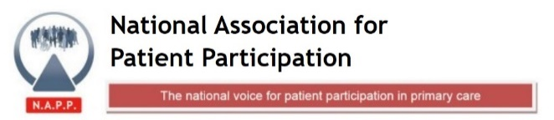
Green initiative
One of the priorities in our practice plan for this year is combatting climate change. As part of this we have been researching how to recycle medical devices. First Asthma inhalers…
Asthma Inhaler Recycling
If you would like to recycle your inhalers you can hand them in as part of the “Complete The Cycle” recycling scheme, run by GlaxoSmithCline.
Hand them in at pharmacists’ counters at branches of Boots, Superdrug, ASDA, Tesco and at L Rowland & Co (Histon Road, Cambridge).

Preventative Healthcare Initiatives
One of our practice plan priorities this year is to promote preventative healthcare and healthy living for our population. Below are two of our initiatives in this area.
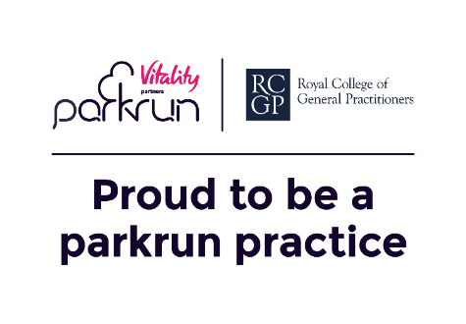

Chariots of Fire Race
We again entered a staff team in the Chariots of Fire race, which took place in September 2019.
Our Chariots of Fire staff team finished in the top 30% of racers this year. The charity race follows in the footsteps of the heroic Harold Abrahams, a Cambridge runner. His bid to win a gold medal in the 1924 Olympics was later retold in the famous film “Chariots of Fire”.
We plan to enter again next year and would love patient teams to join us in the race.

Huntingdon Road Surgery Staff and Patients’
Coldham’s Common Parkrun
We have signed up to the Royal College of General Practitioners Parkrun Practice initiative.
We are going to choose a regular day when Practice staff will go to the Coldham’s Common parkrun, and we invite our patients to join us.
Parkruns are not races:
walk, jog, run, volunteer or spectate

Parkrun is open to all,
including those who are inactive
or have health conditions

If you would like to come along, but would struggle to manage a walk or run of 5km, please do get in touch: coldhamscommonhelpers@parkrun.com We would like lots of volunteers to join us at the start and finish, to encourage people, and to cheer when they reac the end. We look forward to seeing you there!

